Week 4 – Database Management Systems
Topic: Functional Dependencies, Redundancy and Data Anomalies
Context: Online Order Management System

1. Introduction
In an Online Order Management System, data is stored in tables such as Customer, Orders, and Products. Poor design leads to redundancy and anomalies. Functional dependencies help identify relationships and improve database structure.

2. Functional Dependency (FD)

Definition
A functional dependency exists when one attribute uniquely determines another.
Notation:
A → B

Example
CustomerID → CustomerName

3. Sample Table (Unnormalized)
CREATE TABLE Orders (
OrderID INT,
CustomerID VARCHAR(10),
CustomerName VARCHAR(50),
ProductID VARCHAR(10),
ProductName VARCHAR(50),
Quantity INT
);

Insert Sample Data
INSERT INTO Orders VALUES
(101, 'C1', 'Ravi', 'P1', 'Laptop', 1),
(102, 'C1', 'Ravi', 'P2', 'Mouse', 2),
(103, 'C2', 'Arun', 'P1', 'Laptop', 1);

4. View Data (Redundancy)
SELECT * FROM Orders;

Result
OrderID | CustomerID | CustomerName | ProductID | ProductName | Quantity
101 | C1 | Ravi | P1 | Laptop | 1
102 | C1 | Ravi | P2 | Mouse | 2
103 | C2 | Arun | P1 | Laptop | 1
Observation: CustomerName and ProductName are repeated, causing redundancy.

5. Data Anomalies with Queries

5.1 Update Anomaly
UPDATE Orders
SET CustomerName = 'Ravi Kumar'
WHERE CustomerID = 'C1';

Result
OrderID | CustomerID | CustomerName
101 | C1 | Ravi Kumar
102 | C1 | Ravi Kumar
Issue: Multiple rows must be updated.

5.2 Insertion Anomaly
INSERT INTO Orders (CustomerID, CustomerName)
VALUES ('C3', 'Suresh');
Result: Error (missing OrderID, ProductID).
Cannot insert customer alone.

5.3 Deletion Anomaly
DELETE FROM Orders WHERE OrderID = 103;

Result
Customer ‘Arun’ data is lost if this was the only record.

6. Identifying Functional Dependencies
From table:
- CustomerID → CustomerName
- ProductID → ProductName
- OrderID → CustomerID

7. Reducing Redundancy (Normalization Idea)

Create Separate Tables
CREATE TABLE Customer (
CustomerID VARCHAR(10),
CustomerName VARCHAR(50)
);
CREATE TABLE Product (
ProductID VARCHAR(10),
ProductName VARCHAR(50)
);
CREATE TABLE Orders_New (
OrderID INT,
CustomerID VARCHAR(10),
ProductID VARCHAR(10),
Quantity INT
);

Insert Data
INSERT INTO Customer VALUES ('C1','Ravi'), ('C2','Arun');
INSERT INTO Product VALUES ('P1','Laptop'), ('P2','Mouse');
INSERT INTO Orders_New VALUES
(101,'C1','P1',1),
(102,'C1','P2',2),
(103,'C2','P1',1);

8. Retrieve Data Using JOIN
SELECT O.OrderID, C.CustomerName, P.ProductName, O.Quantity
FROM Orders_New O
JOIN Customer C ON O.CustomerID = C.CustomerID
JOIN Product P ON O.ProductID = P.ProductID;

Result
OrderID | CustomerName | ProductName | Quantity
101 | Ravi | Laptop | 1
102 | Ravi | Mouse | 2
103 | Arun | Laptop | 1
Observation: No redundancy, data is normalized.

9. Conclusion
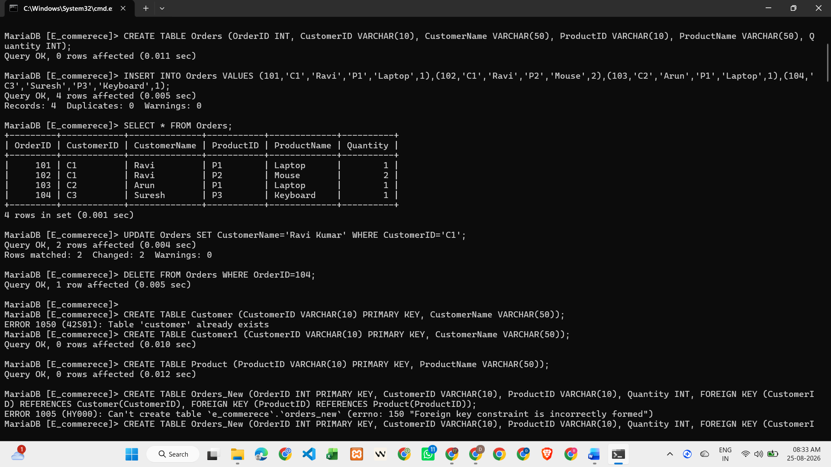
Functional dependencies help identify relationships between attributes. Redundancy leads to anomalies such as insertion, update, and deletion issues. Using proper design and normalization, these problems can be avoided. SQL queries help demonstrate both problems and solutions effectively.

